

***NOTE: This template was designed with patients for improved readability and understanding. It was not designed to replace your localised patient information but contains sections that you may find useful to include.***

# **COVID Oximetry @home service**

# You have been given a pulse oximeter and this leaflet will tell you how and when to use it. COVID-19 can cause low blood oxygen levels. Measuring your blood oxygen level is the most accurate way of monitoring this.

Your doctor has given you or your carer this pulse oximeter and a diary to record the results at home.

# What is a pulse oximeter?

A pulse oximeter measures the level of oxygen in your blood. It can also measure the speed your heart is beating (known as pulse rate).

An ideal blood oxygen level is between 95% and 100%

An ideal heart rate (pulse) is between 50 and 90 beats per minute (bpm).

# How to use a pulse oximeter

It is important that you use your pulse oximeter as instructed to get an accurate reading. Please follow the instructions below for how to use your pulse oximeter correctly:

* Remove any nail polish or false nails (false nails or nail varnish can affect how the oximeter works).
* Make sure you are sat down for at least five minutes before taking your measurement.
* 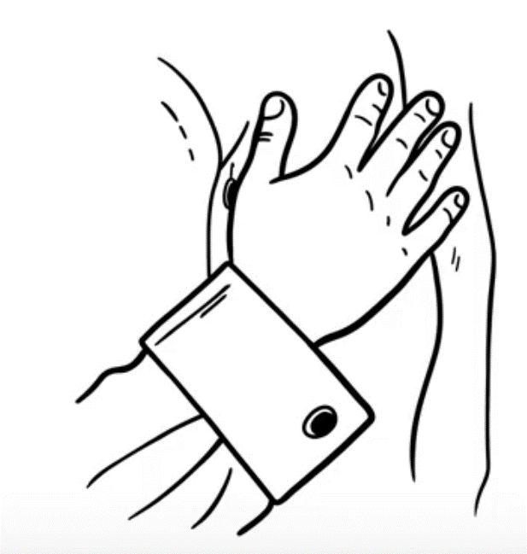Warm your hand if it is cold.
* Switch the pulse oximeter on and place it on your finger. It should be placed on your middle or index finger (see diagram).
* Rest your hand in the middle of your chest and hold still for at least one minute or longer if the reading keeps changing.
* Record the result once the reading has not changed for five seconds.
* 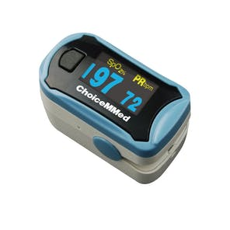Be careful to identify which reading is your heart rate and

which is your oxygen level.

Blood oxygen level (Sp02)

Heart

rate (pulse)

There are videos online to watch if you would like more help. Please see links on the final page of this leaflet.

Before using the pulse oximeter.

This pulse oximeter has been cleaned before it has been given to you. It is for your use only.

Keep it in the bag it came in.

Each time the pulse oximeter is used, you (and anyone who is helping you) should WASH YOUR HANDS in warm soapy water for at least 20 seconds.

* Once your hands are **dry**, remove the device from the bag.
* Please do not attempt to clean inside the pulse oximeter - this risks damaging it.

# Recording and acting on the results

Record your results in the COVID diary at the end of this document.

Take measurements three times a day, at roughly the same time each day – for example when you normally eat in the morning, at lunchtime and in the evening.

Take extra measurements if you feel there has been a change in your health. Please record how in the diary if your breathing is better, worse or the same from the last time you took a reading.

As you get better you may be advised to reduce the number of times each day you take your measurements.

What the readings mean (*please add in your specific escalation instructions here)*

|  |  |
| --- | --- |
| Blood oxygen level | What you should do  **In hours & Out of hours** |
| **95% and above** | Continue monitoring and recording in the diary |
| **93% and 94%** |  |
| **92% and below** |  |

**If you feel well but your blood oxygen is below 95%, rest for a further 5 minutes and repeat the measurement. If it is still below 95% follow the instructions in the table above.**

## Recording your heart rate is useful for your doctor or nurse.

## Recording your temperature is also useful for your doctor or nurse (but only if you already have a thermometer).

## \*\*\**Each CCG can choose whether to include this safety netting or adjust pending this local SOPs\*\*\**

## What to do if you experience the following symptoms

**Attend your nearest A&E within an hour or ring 999 if:**

* You are **unable to complete short sentences when resting** due to breathlessness.
* Your **breathing suddenly worsens** within an hour or very suddenly.

**OR** if these more general signs of serious illness develop:

* + you are coughing up blood
  + you have blue lips or a blue face
  + you feel cold and sweaty **with** pale or blotchy skin
  + you have a rash that does not fade when you roll a glass over it
  + you collapse or faint
  + you become agitated, confused or very drowsy
  + you have stopped peeing or are peeing much less than usual

**If you need to access 999 using a text relay, you can call 18000**

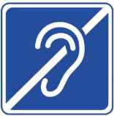

**Ring your GP/NHS 111/OOH pathway *(insert individual pathway here*) as soon as possible if:**

* You slowly start feeling **more unwell or more breathless** for two or more hours.
* You are having difficulty breathing when getting up to go to the toilet or similar.
* Severe muscle aches, shakes or shivers
* You sense that something is wrong (general weakness, extreme tiredness, loss of appetite, reduced urine output, unable to care for yourself – simple tasks like washing and dressing or making food).

# Returning the pulse oximeter

Once you have been told to stop using the pulse oximeter,please return your pulse oximeter and COVID diary to ***(insert local guidance here).*** This will help the NHS learn how best to help other patients with COVID-19.

If you are shielding please ask a friend or volunteer to do this for you. You should return it in the bag/envelope provided so that it can be safely cleaned and given to other patients.

Links to videos on how to use a pulse oximeter:

***(Note: you may choose to use these videos as they do not include any escalation processes just focus on how to use the Oximeter itself)***

Here are some links to videos on how to use a pulse oximeter. If you have a paper copy of this leaflet you can type the web address into your internet browser.

English <https://bit.ly/3qUxaTs>

Polish (Polski) <https://bit.ly/3lSxRsw>



Hindi <https://bit.ly/3ovb3B4>



Punjabi <https://bit.ly/3mWj4hW>



Urdu <https://bit.ly/33Rr0cS>

Remote monitoring COVID-19 diary

First name Surname

Date of birth Age NHS number (if known)

Live alone ☐ Carer at home ☐

## Please record these three times a day

|  |  |  |  |  |  |  |  |
| --- | --- | --- | --- | --- | --- | --- | --- |
| Days since first symptoms ★ | | Date | Heart rate (pulse) | Oxygen level  % | Temperature*(only if you have a thermometer) | Feeling: better/same/ worse | Breathing: better/same/ Worse |
| Day | Time |
| First reading | |  |  |  |  |  |  |
|  |  |  |  |  |  |  |  |
|  |  |  |  |  |  |  |  |
|  |  |  |  |  |  |  |  |
|  |  |  |  |  |  |  |  |
|  |  |  |  |  |  |  |  |
|  |  |  |  |  |  |  |  |
|  |  |  |  |  |  |  |  |
|  |  |  |  |  |  |  |  |
|  |  |  |  |  |  |  |  |
|  |  |  |  |  |  |  |  |
|  |  |  |  |  |  |  |  |
|  |  |  |  |  |  |  |  |
|  |  |  |  |  |  |  |  |
|  |  |  |  |  |  |  |  |

★ That is, if you start recording pulse oximetry five days after your first symptoms started, record ‘5’ under Day.

* Record and fill in temperature if you have a thermometer.

**As all models are slightly different patients are to additionally ensure they carefully read the instructions provided with the oximeter**

|  |  |  |  |  |  |  |  |
| --- | --- | --- | --- | --- | --- | --- | --- |
| Days since first symptoms ★ | | Date | Pulse | Oxygen level  % | Temperature* | Feeling: better/same/ worse | Breathing: better/same/ Worse |
| Day | Time |
|  |  |  |  |  |  |  |  |
|  |  |  |  |  |  |  |  |
|  |  |  |  |  |  |  |  |
|  |  |  |  |  |  |  |  |
|  |  |  |  |  |  |  |  |
|  |  |  |  |  |  |  |  |
|  |  |  |  |  |  |  |  |
|  |  |  |  |  |  |  |  |
|  |  |  |  |  |  |  |  |
|  |  |  |  |  |  |  |  |
|  |  |  |  |  |  |  |  |
|  |  |  |  |  |  |  |  |
|  |  |  |  |  |  |  |  |
|  |  |  |  |  |  |  |  |
|  |  |  |  |  |  |  |  |
|  |  |  |  |  |  |  |  |
|  |  |  |  |  |  |  |  |
|  |  |  |  |  |  |  |  |
|  |  |  |  |  |  |  |  |
|  |  |  |  |  |  |  |  |
|  |  |  |  |  |  |  |  |
|  |  |  |  |  |  |  |  |
|  |  |  |  |  |  |  |  |

**As all models are slightly different patients are to additionally ensure they carefully read the instructions provided with the oximeter**